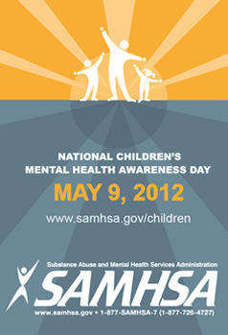
April 26, 2012
AMTA Participates in SAMHSA Children’s Mental Health Awareness Day 2012
AMTA is a regular participant in the Substance Abuse and Mental Health Services Administration (SAMHSA), Children’s Mental Health Awareness Day; being held this year on May 9, 2012. (http://www.samhsa.gov/children/) Each year, it is the communities' creativity and innovation that capture the essence of Awareness Day.
In 2011, more than 1,100 communities held events for Awareness Day. Events included community events, youth rallies, social media campaigns, and art, dance, and music related activities for children and youth. Every Awareness Day event aimed to raise awareness about the importance of children's mental health. For 2012, they are focusing on "Heroes of Hope", highlighting children birth to 18 yrs., who have demonstrated resilience in dealing with trauma in their lives.
SAMHSA would like to include suggested music activities related to incorporate into the Children’s Mental Health Awareness Day experience. {If you were to do an event that involved music, what would it look like?} While we are not permitted to use the word "therapy" there are several ways to characterize our goals and intentions. (ex. enhancing lives, building resilience, enables parents to engage with their children, etc.) The events can be for small or large groups within the community.
If you are inspired to host your own Awareness Day 2012 activity, fill out and submit your pledge form (http://www.samhsa.gov/children/Pledge_insert_2012_508.pdf )to share your plans with SAMHSA and the Caring for Every Child's Mental Health Campaign team.
Please let us know if you host an event in your area. We would love to hear about it!! Details or a copy of your pledge form can be emailed to AMTA Government Relations Associate, Rebecca Smith at smithr@musictherapy.org We would love to hear about it!!

