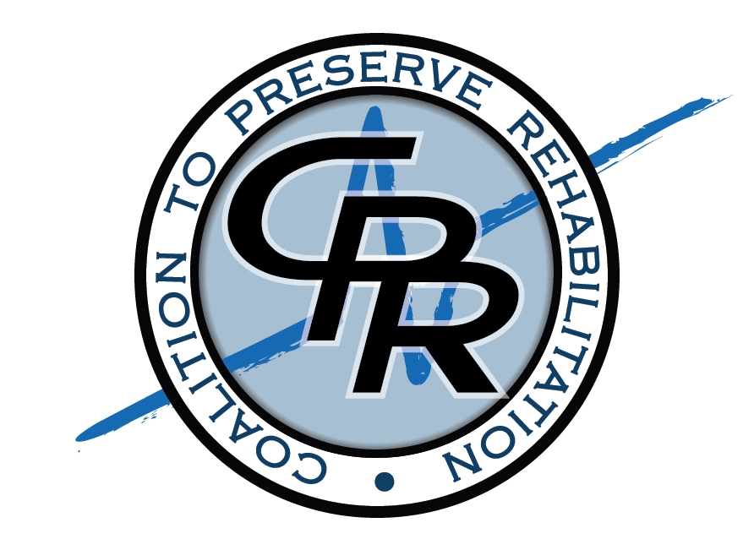

PRESS RELEASE Contact:
FOR IMMEDIATE RELEASE Kristen Piehl: 202-349-4276
November 1, 2011 kristen.piehl@ppsv.com

Congressional Briefing:
Protecting the Future of Medicare Rehabilitation

Senator Tim Johnson (SD), Lee Woodruff of the Bob Woodruff Foundation, and Jordan Thomas, double amputee and CNN “Hero” from the Jordan Thomas Foundation will lead a Congressional Briefing today on the value of medical rehabilitation services after injury or illness. Each will speak of his or her own experience with rehabilitation and how intensive, hospital-based rehabilitation has touched their lives.

The Coalition to Preserve Rehabilitation (CPR), including the organizations listed below, will join Senator Johnson in hosting the event entitled, “Protecting the Future of Medicare Rehabilitation.” It will be held on Tuesday, November 1st, 12:00 noon to 1:00 p.m. in Room B-340 of the Rayburn House Office Building.

These personal accounts of injury, healing, rehabilitation, and triumph will underscore concerns with Medicare proposals pending before the “Super Committee” and Congress that would severely restrict access to inpatient rehabilitation hospital services. These proposals would reduce future investments in inpatient hospital rehabilitation and restrict access to these services in order to produce short-term savings for the federal government at the expense of patients.

“As someone who has seen the benefits of intensive rehabilitation services first-hand, it is important to make sure people understand the value of rehabilitation and how the federal investment in rehabilitation hospital services is cost-effective in the long term,” stated Senator Tim Johnson, who in 2006 sustained a near fatal brain hemorrhage.

Lee Woodruff added, “My husband and I have been on the front lines of maximizing what rehabilitation has to offer. I shudder to think about those in future need after an illness or injury who may not have access to intensive, inpatient rehabilitation care.” Ms. Woodruff is the wife of Bob Woodruff, the ABC News correspondent who sustained a traumatic brain injury in 2006 from a roadside bomb while covering a story in the Iraq War.

Jordan Thomas, a bilateral below-the-knee amputee, will speak to his experience with inpatient rehabilitation care. “After I lost my legs,” Jordan stated, “I was able to get back on track quickly and it all started with inpatient hospital rehabilitation. Anyone who goes through something like that knows the value of these services and I am speaking today to make sure access to this level of care is preserved in the future.”

Judith Stein, J.D., Executive Director of the Center for Medicare Advocacy, a leader of the Coalition to Preserve Rehabilitation, said, “Access to inpatient hospital rehabilitation is an issue we have been fighting for years and the need has never been greater to preserve this level of care for Medicare beneficiaries and all Americans. We understand the magnitude of the problems our country has with the federal debt, but cutting access to rehabilitation hospital care is penny wise and pound foolish.”

Before and after today’s Congressional Briefing, cutting edge rehabilitation technologies for people with spinal cord injuries, amputations and other disabilities will be featured. The technology demonstration will include cutting edge technologies from the following:

- Madonna Rehabilitation Hospital (featuring ICARE: Intelligently Controlled Assistive Rehabilitation Elliptical)
- MossRehab, Einstein Healthcare Network (featuring ReWalk)
- iWalk (featuring the PowerFoot BiOM)
- National Rehabilitation Hospital, MedStar Health (featuring HandSOME and ZeroG)
- Tibion Corporation (demonstrating the Tibion Bionic Leg)

The Coalition to Preserve Rehabilitation (CPR) is a coalition of national consumer, clinician and membership organizations with the goal of preserving access to medical rehabilitation services. CPR will advocate for policies that ensure access to rehabilitative care so that individuals with disabilities, injuries or chronic conditions may regain and/or maintain their maximum level of function and live as independently as possible. Further information about the briefing and related materials can be found on the CPR website: www.preserverehab.org

Members of the CPR Coalition and Supporters of the Congressional Briefing Include:

ADAP ADVOCACY ASSOCIATION (aaa+)
American Academy of Physical Medicine & Rehabilitation
American Association of People with Disabilities
American Association on Health and Disability
ACCSES
American Congress of Rehabilitation Medicine
American Medical Rehabilitation Providers Association
American Music Therapy Association
American Occupational Therapy Association
American Physical Therapy Association
American Speech-Language-Hearing Association
American Therapeutic Recreation Association
Amputee Coalition of America
Association of Academic Physiatrists
Association of Assistive Technology Act Programs
Brain Injury Association of America
Center for Medicare Advocacy
Christopher & Dana Reeve Foundation
Disability Rights Education & Defense Fund
EasterSeals
Hearing Loss Association
National Association for the Advancement of Orthotics and Prosthetics
National Association of State Head Injury Administrators
National Council on Independent Living
National Disability Rights Network
National Multiple Sclerosis Society
National Rehabilitation Association
RESNA
Spina Bifida Association
The Arc of the United States
United Cerebral Palsy
United Spinal Association
###

