August 17, 2016 Silver Spring, MD

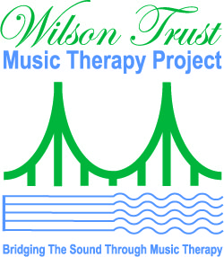
The Wilson Trust Music Therapy Project (WTMTP) is a program of the American Music Therapy Association (AMTA). Site visits held this month to grantees reveal significant progress in expanding services to individuals in the Puget Sound region of the Pacific Northwest. Meetings took place among grant awardees at Seattle Children’s Hospital, University of Washington, Seattle Pacific University’s music therapy program, Snohomish County Music Project, the University of Washington Medical Center, and with leadership of the Music Therapy Association of Washington.

Project Director, Barbara Else commented, “WTMTP represents a model for growing quality services for underserved populations. The program hinges upon objectives to support music therapy sustainability, technical assistance to area professionals, partnership and collaboration, and accountability.”

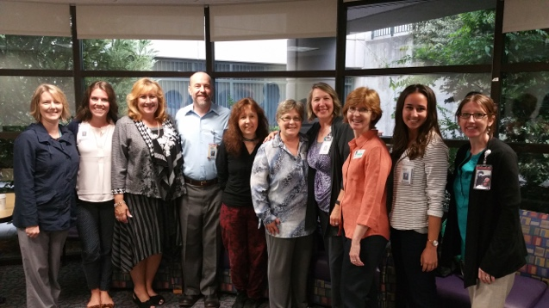
David Knott, MT-BC and music therapist at Seattle Children’s Hospital noted the WTMTP program funds “helped Seattle Children's establish a music therapy position dedicated to serving our Cancer Care unit. With that support, the following year found a 400% increase in music therapy services provided to our young patients experiencing treatment for cancer. Wilson Trust enabled a quantum leap in the development of the music therapy service at Seattle Children's.”
Pictured: Seattle Children’s Hospital Team with AMTA WTMTP staff.

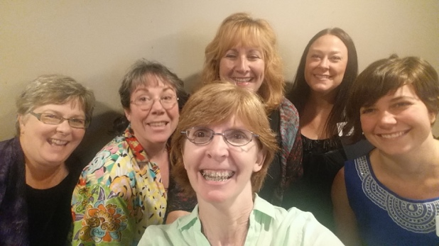
Vasheti Quiros, Executive Director at the Snohomish County Music Project, commented that the matching grant award, “has been instrumental (pun intended) in the expansion of music therapy services to vulnerable populations throughout Snohomish County… support has enabled us to increase our capacity, serving 152% more people in 2016 who would not otherwise have access to these services."
Pictured: Snohomish County Music Project team with AMTA WTMTP staff

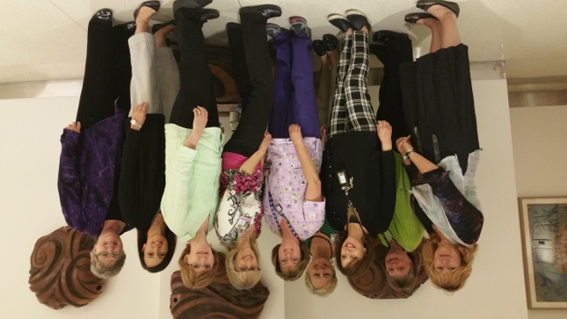
The most recent award at the University of Washington Medical Center enabled the addition of a part-time Board Certified Music Therapist serving patients in palliative care and on Medical-Surgery/Pain units at the Medical Center.
Pictured: University of Washington team with nursing staff and AMTA WTMTP staff

Since the inception of the WTMTP in late 2011, 21 small grant awards were given to practicing clinicians and to supporting the expansion of music therapy practica programs offering supervised music therapy services in the community by students completing their education and training program at Seattle Pacific University. SPU is an anchor for music therapy in Washington and these small grants contributed to expanded music therapy services to a wide range of clientele throughout the region.

The site visits held in August, 2016 served to inform a midcourse review. Additional program awards are expected in the future. WTMTP is based on a $400,000 legacy gift given to the AMTA by the Eleanor and Raymond Wilson Charitable Trust to expand access to, and grow, sustainable music therapy services in the Puget Sound Region of Washington State. Mrs. Eleanor Wilson was a passionate advocate for music and the environment. The Wilsons resided in the Puget Sound region and supported numerous music and arts programs in the greater Seattle area. Information on the WTMTP and program awardees may be found on the AMTA website: See: http://www.musictherapy.org/about/grant_donor_support/
Pictured with AMTA WTMTP staff is Carlene Brown, PhD, MT-BC, Associate Professor and Chair of the Music Department at Seattle Pacific University.

Contacts:
Patti Catalano, MM, MT-BC
WTMTP, Regional Project Manager
catalano@musictherapy.org

Barbara A. Else, MPA, LCAT, MT-BC
WTMTP, National Project Director
else@musictherapy.org

###

